Databricks Apps

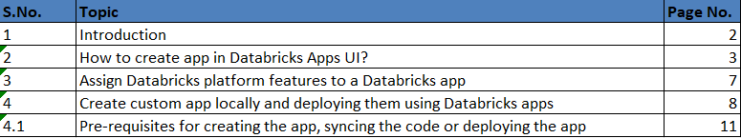

Introduction:
Databricks Apps allows developers to build secure data and AI applications directly on the Databricks platform and share them with others. Before this, developers had to set up separate infrastructure for apps, manage security, and follow data governance rules. Now, Databricks hosts these apps, removing the need for extra setup.
Before Databricks Apps, creating data and AI applications that connected to Databricks workspaces was a bit more complex and required multiple steps. Developers had to set up separate infrastructure outside of Databricks to host their applications. This setup involved handling data governance and security requirements on their own meaning they had to ensure each app met security rules, managed authentication (like logins and access permissions), and authorization (who could do what with the data).
After Introduction of Databricks Apps:
With Databricks Apps, all of that setup becomes easier because Databricks itself hosts the applications directly on its platform. This removes the need for extra infrastructure, as Databricks takes care of security, governance, and access controls for you. Applications can use built-in Databricks features like:
- Unity Catalog: For managing data governance (who has access to which data).
- Databricks SQL: For querying data stored in Databricks.
- AI model serving: For deploying AI models to make predictions.
- Databricks Jobs: For running ETL (Extract, Transform, Load) jobs or data pipelines.
Databricks Apps are developed in Python, which means they can be built using popular frameworks like Dash, Streamlit, Gradio, Shiny, or Flask. Once built, you can create, test, and move your apps between Databricks workspaces, making them flexible and easily portable.
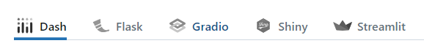

How to create app in Databricks Apps UI?
- In the sidebar select the Compute and then select the Apps in it.
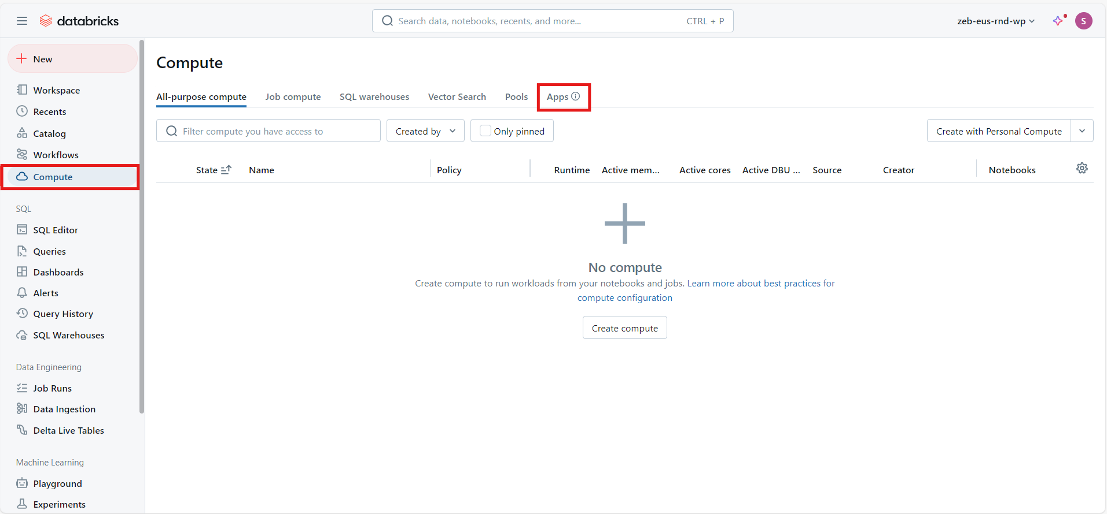

- You can view the list of already created apps (if created), click on the Create app on the top right corner.
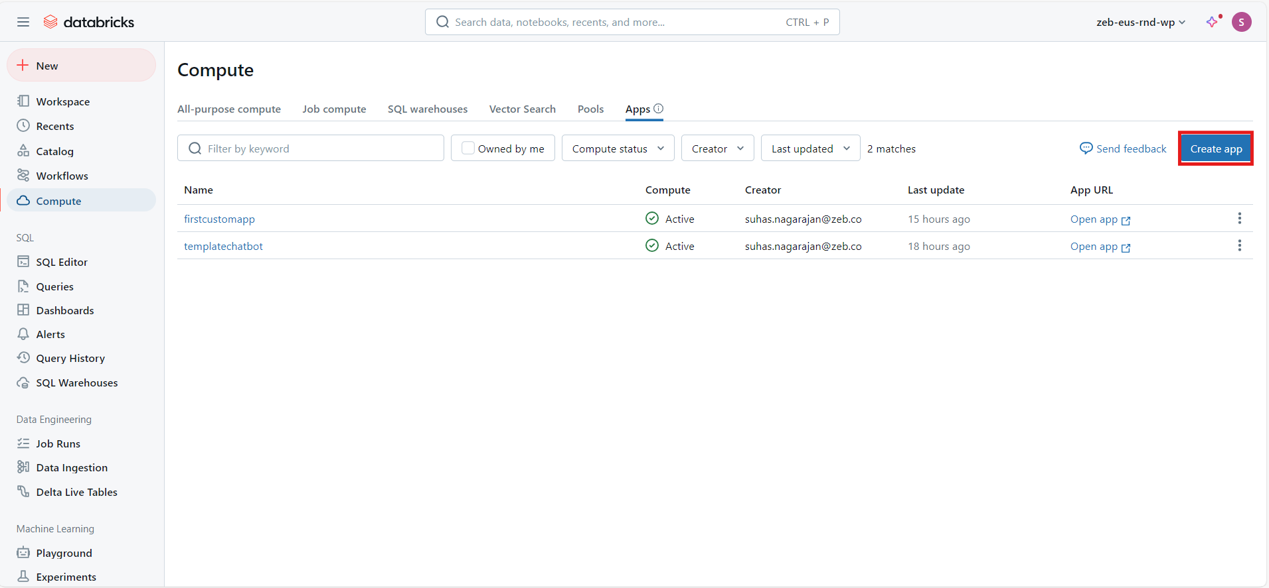

- You can either use a pre-defined template for the app or you can create your own app locally in vs code.
  - To start with an example app, select Template, click the tab for your preferred framework, and select from the list of apps.
  - To create an app using your code, select Custom.
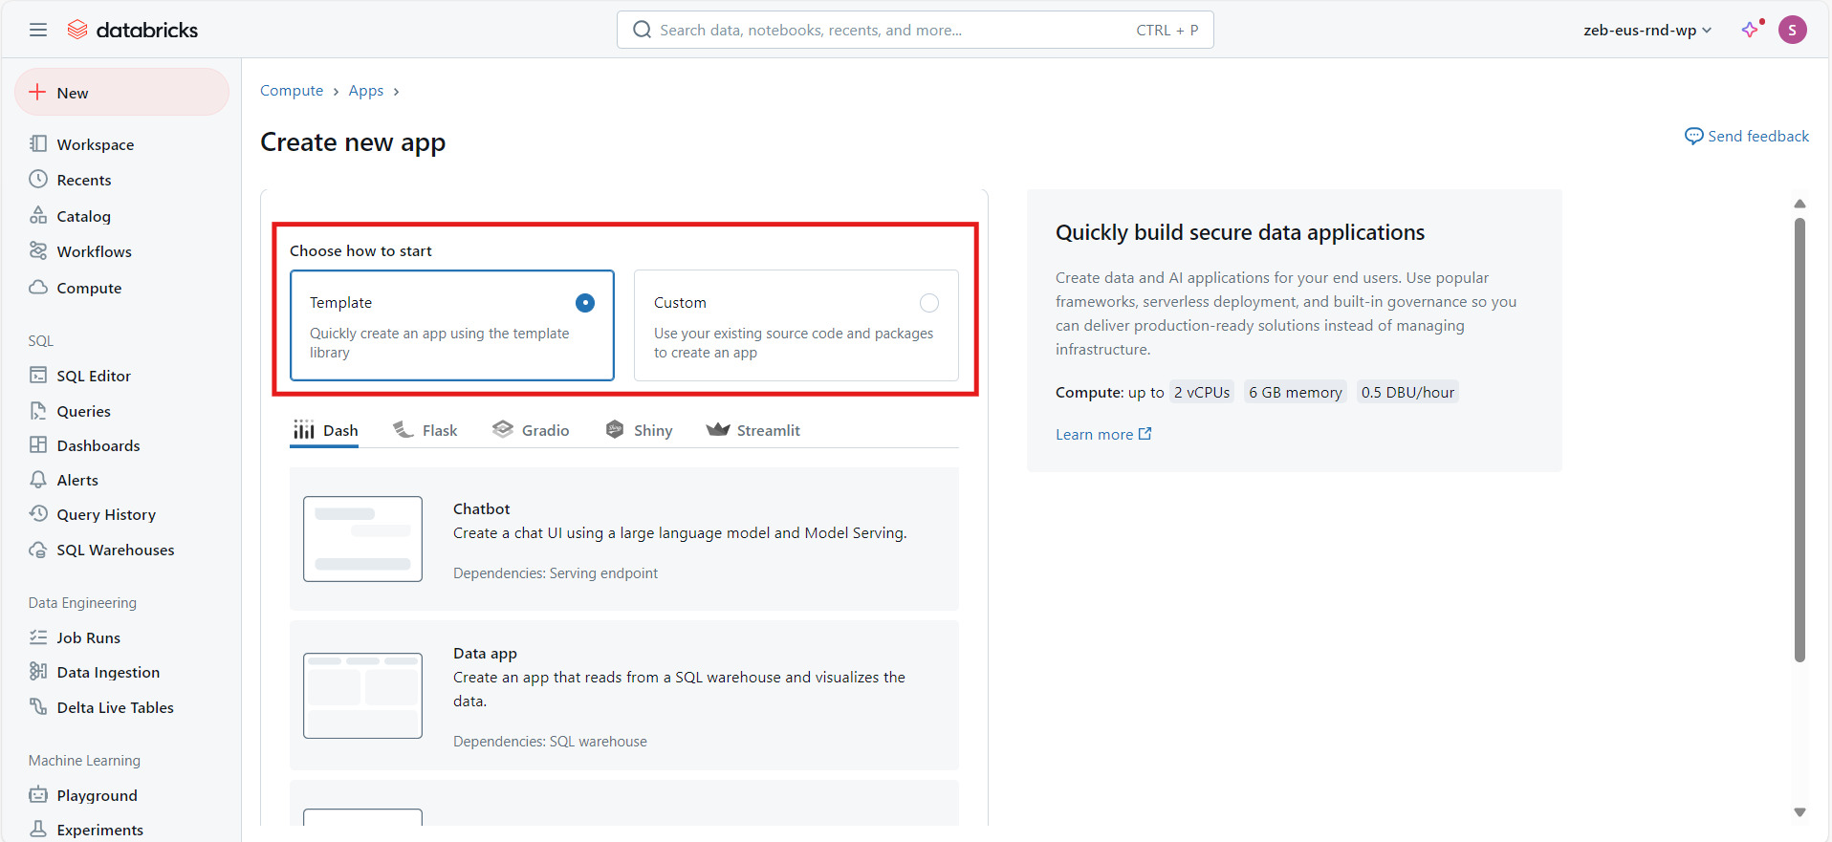

- Click on Next, In the App name field, enter a name for the app and optionally enter a description. The app name should only contain lowercase letters, numbers and hyphens
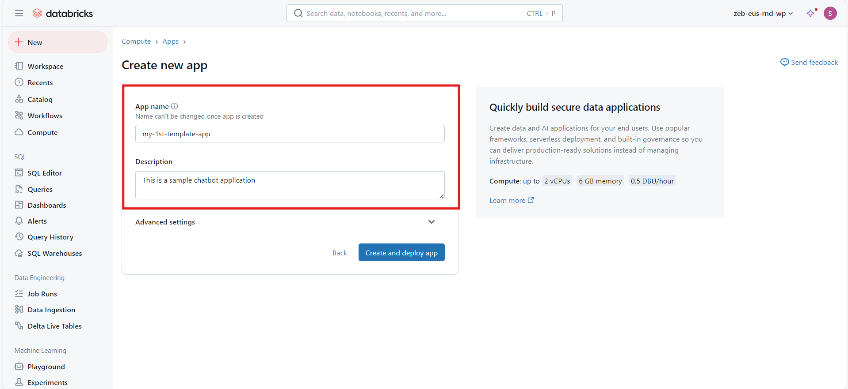

- Click on the Advanced Settings, under which you can select the resources need for you app to run (In this case for a chatbot to run I will select any served model). Then click on Create and Deploy app.
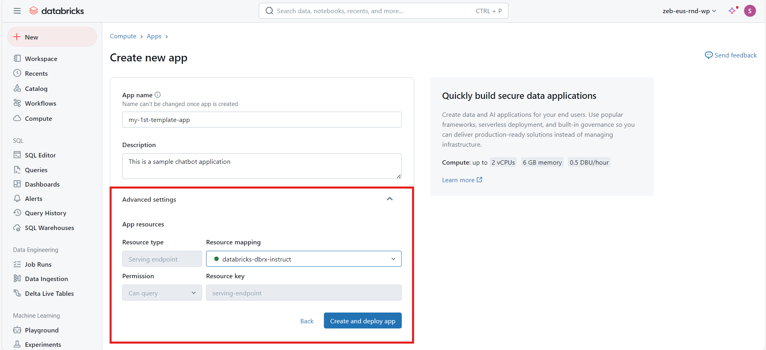

- If you have selected the Custom, then provide name and description(optional) to the app and if you need any additional resources, you can select them too. After configuring it you can click on Create app for creating your app.
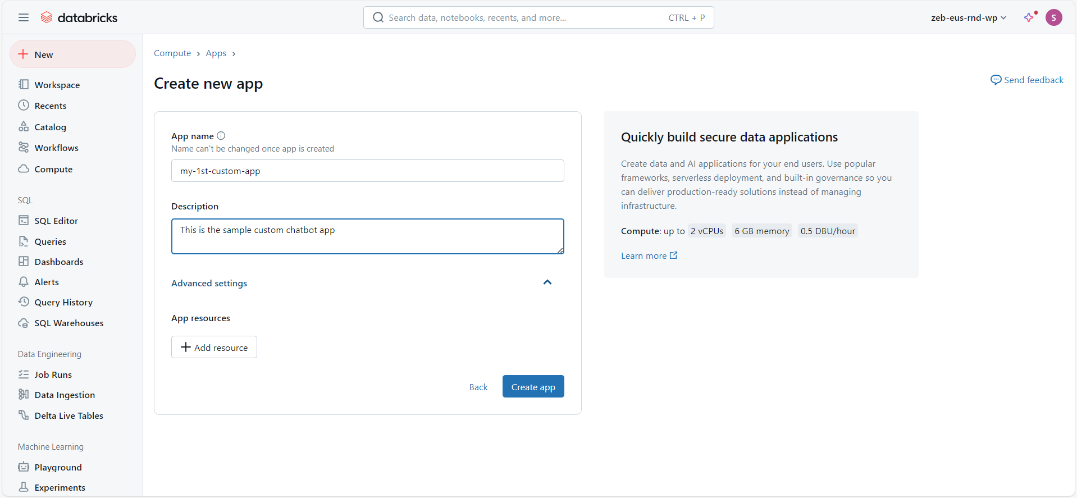
When you click Create and deploy app or Create app in Databricks, it opens the app details page. If you choose a Template, Databricks automatically sets up your app with example code and necessary configurations.
The app details page shows:
- App Status: Updates on the app's creation and deployment status.
- Development Steps: Instructions for continuing development locally, including how to copy app files (artifacts) to your local setup and sync changes back to the Azure Databricks workspace.
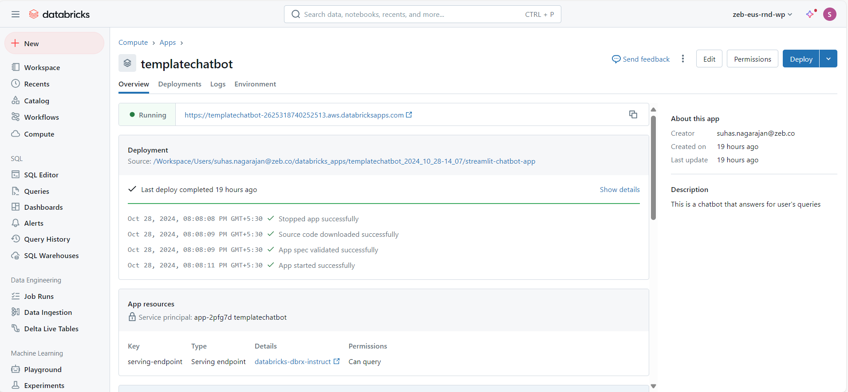
If you choose the Custom option when creating an app in Databricks, Databricks creates a basic app structure, but you’ll need to add your own code and files (artifacts) to complete it. After adding these, you’ll also need to deploy the app separately.
The app details page for a custom app shows:
- App Status: Information on the creation status of the app.
- Sync & Deployment Steps: Instructions for syncing your app's code and files from your local setup to the Azure Databricks workspace and for deploying the app.
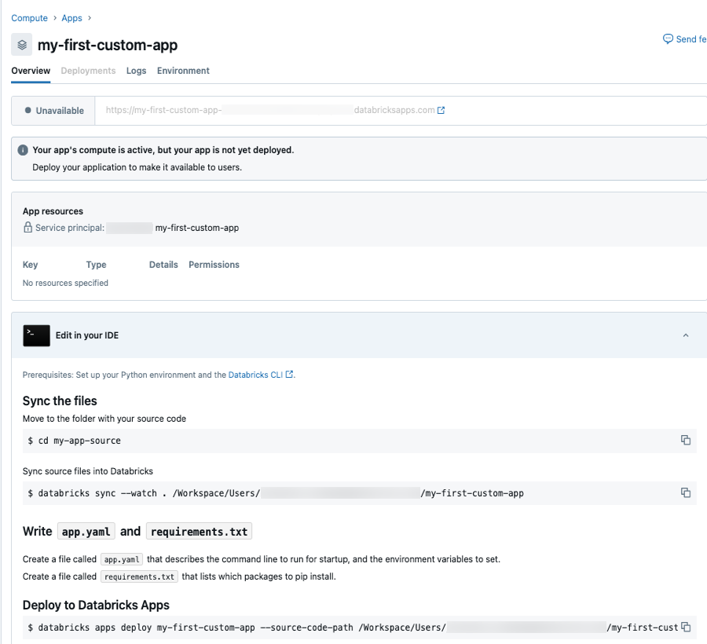
Assign Databricks platform features to a Databricks app:
To assign Databricks platform features like Databricks SQL, Databricks Jobs, AI Model Serving, or Databricks Secrets to your app, add them as resources when creating or editing the app:
- In Create new app or Edit app, go to Advanced settings and click + Add resource.
- Choose the resource type (e.g., SQL warehouse, Jobs, etc.) and fill out the required fields, including the Resource key. This key will later reference the resource.
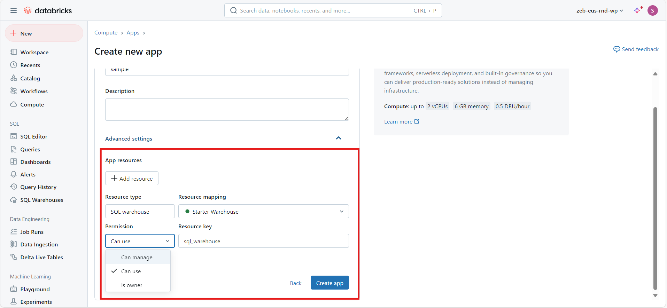
Example: Adding a SQL Warehouse Resource
- Save the resource setup.
- In the app's app.yaml file, add an entry that references the resource by using valueFrom, which points to the source of the value rather than the actual value itself.
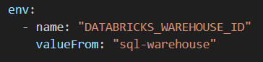
- To use this resource in your app code, access the DATABRICKS_WAREHOUSE_ID by calling it as an environment variable:
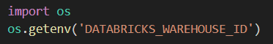
Create custom app locally and deploying them using Databricks apps:
- In a text editor or your favorite integrated development environment (IDE), create a new Python file with the following code and save it to the directory you created. This example uses the filename app.py for the Python file:

- import streamlit as st
- import requests
- import json
- import boto3

- # Function to call GPT-4 API (replace with your actual API call)
- def call_llm(Prompt):
- try:
- client = boto3.client("bedrock-runtime", region_name="us-east-1", aws_access_key_id= "access_key", aws_secret_access_key= "secret_key")
- model_id = "anthropic.claude-3-5-sonnet-20240620-v1:0"
- native_request = {
- "anthropic_version": "bedrock-2023-05-31",
- "max_tokens": 1500,
- "temperature": 0.5,
- "messages": [
- {
- "role": "user",
- "content": [{"type": "text", "text": Prompt}],
- }
- ],
- }
- request = json.dumps(native_request)
- response = client.invoke_model(modelId=model_id, body=request)
- model_response = json.loads(response["body"].read())
- response_text = model_response["content"][0]["text"]
- return response_text
- except Exception as e:
- print(f"Error in call_llm: {e}")
- return None

- # Set page config
- st.set_page_config(page_title="AI Assistant", page_icon=":robot_face:")

- # Initialize chat history
- if 'messages' not in st.session_state:
- st.session_state.messages = []

- # Initialize last_input to keep track of the last processed input
- if 'last_input' not in st.session_state:
- st.session_state.last_input = ""

- # Custom CSS
- st.markdown("""
- <style>
- .chat-message {
- padding: 1.5rem; border-radius: 0.5rem; margin-bottom: 1rem; display: flex
- }
- .chat-message.user {
- background-color: #2b313e
- }
- .chat-message.bot {
- background-color: #475063
- }
- .chat-message .avatar {
- width: 20%;
- }
- .chat-message .message {
- width: 80%;
- padding: 0 1.5rem;
- color: #fff;
- }
- </style>
- """, unsafe_allow_html=True)

- # Header
- st.title("AI Assistant")

- # Display chat messages
- for message in st.session_state.messages:
- with st.container():
- st.markdown(f"""
- <div class="chat-message {message['role']}">
- <div class="avatar">
- <img src="https://i.imgur.com/{'7m1cITm.png' if message['role'] == 'user' else 'v2HtRnN.png'}" style="max-height: 78px; max-width: 78px; border-radius: 50%; object-fit: cover;">
- </div>
- <div class="message">{message['content']}</div>
- </div>
- """, unsafe_allow_html=True)

- # User input
- user_input = st.text_input("Type your message here...")

- if user_input and user_input != st.session_state.last_input:
- # Update last_input
- st.session_state.last_input = user_input

- # Add user message to chat history
- st.session_state.messages.append({"role": "user", "content": user_input})

- # Get bot response
- Prompt = f"""You are an Excellent AI Assistant who helps the user with their query whatever the field it may be.\n\n Find the below user Input : {user_input}"""
- bot_response = call_llm(Prompt)

- # Add bot response to chat history
- st.session_state.messages.append({"role": "bot", "content": bot_response})

- # Rerun to update the display
- st.rerun()

- # Add a button to clear chat history
- if st.button("Clear Chat History"):
- st.session_state.messages = []
- st.session_state.last_input = ""
- st.rerun()

- In a text editor or an IDE, create a new YAML file with the following contents and save it to a file named app.yaml in the directory you created. Replace <app-name.py> with the name of the Python file containing the code for the app. For example, app.py. Replace the <framework> with the python framework you are gonna use.

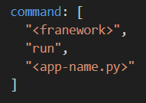

- Test your app locally whether it runs properly.
Pre-requisites for creating the app, syncing the code or deploying the app:
- The Databricks CLI version should be 0.205 or above.
- We will be using winget to automatically download and install the latest Databricks CLI.
- From your Command Prompt, run the following two winget commands to install the CLI, and then restart your Command Prompt:
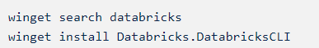
- Confirm whether the Databricks CLI is installed correctly. To do this, view the Databricks CLI executable’s version by using the -v option or by running the version command:
- If a version number of 0.205.0 or above is listed, it means that the Databricks CLI is installed correctly.
- Use the Databricks CLI to run the following command.

- Enter the host URL and access token to authenticate the Databricks CLI
- To create an app in databricks run the following command:
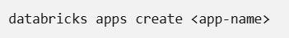
- Replace <app-name> with a name for your app. For example, my-1st-customapp.
- To view the app in your workspace when the create command completes, in the sidebar, click Compute, go to the Apps tab, and click the link to your app in the Name column.
- Sync the files from your local environment to your Databricks workspace. The command to sync the files from your local environment to your workspace, including the workspace path for the files, is under Sync source files into Databricks.
- To view the synced files in your workspace when the sync command completes, click Workspace in the sidebar and go to the directory created for your app.
- To deploy the app, run the following command in a terminal, replacing <app-path> with the workspace path to your app files.

